Larry King: This is Larry King. Tonight me guest is Dean Graziosi. He's a multiple New York Times best-selling author, success trainer, speaking to sold-out crowds around the world. On national TV for over 15 years. A hugely successful entrepreneur and business man. People like billionaires Sir Richard Branson said, "Dean is the type of entrepreneur that makes the world a better place." Tony Robbins said, " Dean's a genius for what he does." This guy is everywhere and ...

Dean Graziosi: Hey this is Dean Graziosi and I had to jump in real quick. First off to say, what an honor and privilege it was to be interviewed by the legendary Larry King. It was a dream come through and to be friends and know millionaires and billionaires and Presidents and world changers, as just been transformational, but this video is not about me, it's about you.

Dean Graziosi: This is one of those times in life you can play small, be scared about the uncertain times. Be afraid you're gonna be left behind or can I really understand the changes that are coming, or you can realize, right now is the greatest time in history for you to build wealth, if you have the right capabilities, if you have the right secrets.

Dean Graziosi: Listen, I don't know if this is the first time you're meeting me, but as a kid, I literally lived in a bathroom with my dad for almost a year with a little electric heater. I lived in a trailer park with my mom. They were married nine times between 'em. I didn't go to college, I didn't have money and I just thought that was my lot in life, but then I got obsessed and I started observing and studying the wealthiest people I knew, the happiest people I knew and I realized they had one thing different than all the rest of us who were struggling. They had a little bit different habits and when I started applying those habits, feeling those habits and putting them in my life, I became a millionaire in my 20's and I've gone on to generate hundreds of millions of dollars in my life, through my brands and through my companies because of these habits and now, I want you to have my best book ever' Millionaire Success Habits for free.

Dean Graziosi: Listen, this isn't my first book. I'm a multiple New York Times best-selling author. I've touched the lives of millions of people around the world, but right now I want you to have this book and here's why I'm doing to. I'd like you to read this book cover to cover and than do me a favor, help spread the word, tell all your friends, email everybody in your database and tell 'em your honest thoughts about this book. I have 'em right here in the warehouse next door, when those copies are gone, this opportunity is gone.

Dean Graziosi: Listen, you could go to Amazon right this minute and get this book for $19.95 and you can read all the five star reviews. This book is on fire. Or you can fill out the information on this page right now and I will ship this book to you, the hard cover for free. I've already paid for to. All I ask is that you cover the shipping and handling,

Dean Graziosi: To do that I have some more ethical bribes to make you take action today to help me get this book out to millions of people. I will also include a 90 minute online training about the new way to wealth. You'll get an invite to that and lastly, I'm helping my dear friend Tony Robbins. He wants to feed a 100 million people this year through Feeding America. Every time I ship a book to you, I will provide 22 meals through Feeding America. We're already over 500,000 meals, on our way to 10,000,000, but this opportunity and this offer will go away.

Dean Graziosi: What you need to do right now is fill out the information on this page. Let me ship you the book. I already paid for it. Cover the shipping and handling, get all the bonuses, feed 22 people and see for yourself, with the right habits, with these small shifts, you can take ownership of your life. You can reach that full potential.

Dean Graziosi: Remember the definition of insanity is doing the same thing over and over again and expecting a different result. If you want to make more money, have more freedom, have more control of your life, you need different capabilities and then take action. I want to give you those capabilities so you can go out and be your best self.

Dean Graziosi: I'm Dean Graziosi. Hurry up and grab this book before it's gone.

**There Are 1,700 New Millionaires Created Every Day In America Alone... Could You Be Next?**

**Get Your FREE Hardcover Copy Of Millionaire Success Habits! - Only While Supplies Last!**

***Here's Everything You Get For FREE:***

* Free **Millionaire Success Habits** Hardcover Book (On Amazon For $19.95)
* Exclusive **“Confidence Builder”** Interview With Tony Robbins (Value $97)
* Dean Will **Donate To Feeding America** And Provide 20 Meals To Those In Need (Priceless)
* Get A**Seat To An Online Webclass Training** Where Dean Will Reveal What He Believes Is The #1 Way To Profit From Today's Economy



* For every book we ship, we also donate 22 meals to those in need through Feeding America - Over 1.5 MILLION meals donated so far



Top of Form

Top of Form

**1**

**SHIPPING**

Where To Ship Book

**2**

**UPGRADE**

Upgrade?

**SHIPPING**

FORM

[**Special Offer Click Here!**Yes! I Want This FREE BOOK Now!](https://dgachieve.com/freebook-in?fbclid=IwAR0RcLqUm9AAqnOCufZW7kOHgupLVw0leofhP_DRvsYylgxotPBdjxYcQU8#submit-form-2step)

I expressly authorize Dean Graziosi to send me emails and text messages about his products or services using automated technology to the email/ number provided on the form above. I understand that I am not required to give my consent as a condition of receiving information or purchasing a product and can opt out anytime.

Bottom of Form

Bottom of Form

**"I'll Pay For The Book,**

**You Cover The Shipping!**

***Tell Me Where To Ship Your FREE Copy Today!"***

***Millionaire Success Habits Will Help You:***

* **Start or scale a side income** so you can work from home and never have to worry about money again
* **Escape debt.**Learn how I escaped over $60,000 in debt so you can escape house payments, student loans, and anything in between
* **Discover the habits of the highest achievers** in the world and how you can follow their paths with just small tweaks to your daily habits.
* **And achieve the life of financial freedom you've always dreamed of!**



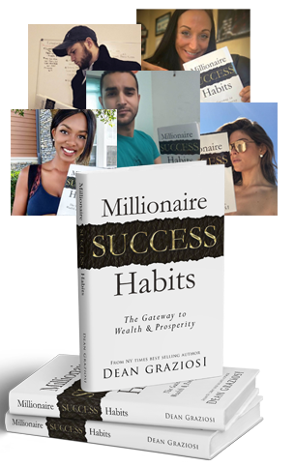

**Hurry, This FREE Offer Won't Last long!**

**How Is This Book Different?                   What Do Others Think?**

*What I love about Dean Graziosi is that he is a GENIUS at what he does and as corny as it sounds he truly cares.*

**- Tony Robbins**

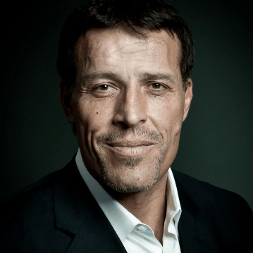

*This book is packed with hard-won wisdom that will transform your life. A must-read for anyone who wants to take control of their life.*

**- Marie Forleo**

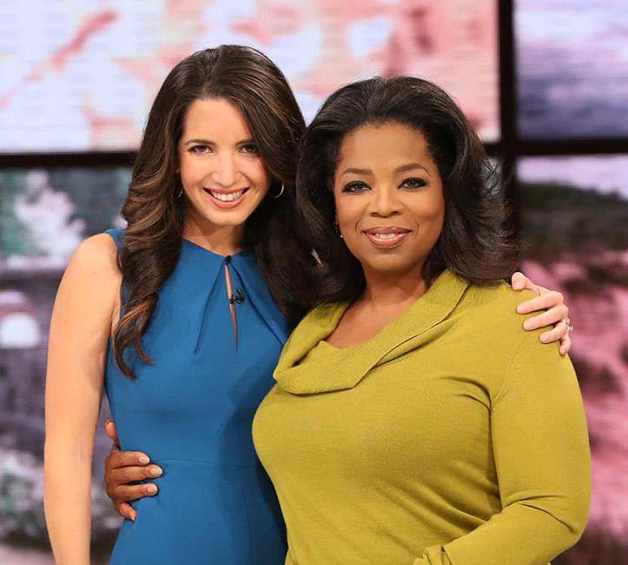

*You should get this book no matter what. I paid this guy $100k to be a part of his mastermind and you can learn from him for just a few bucks!"*

**- Russell Brunson**

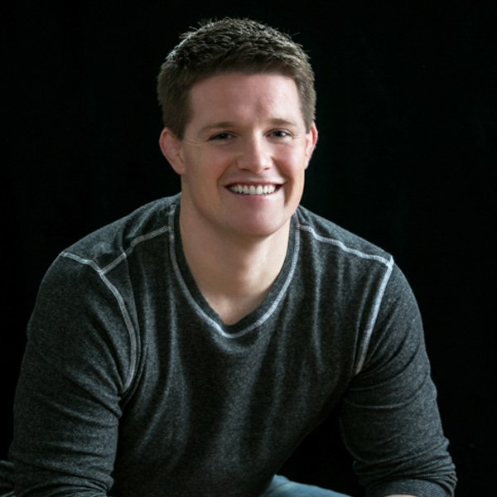

*“In this incredibly inspiring and personal book, Dean gives us the key to greater happiness, wealth and freedom. A must-read.”*

**- Brendon Burchard**

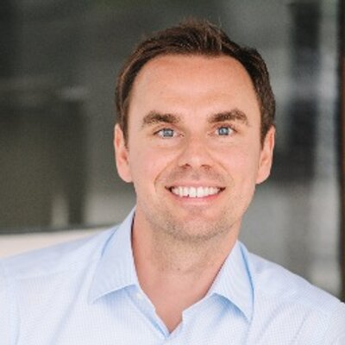

*"It's entrepreneurs like Dean that make the world a better place.*

**- Sir Richard Branson**

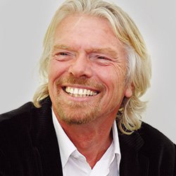

*“Dean has a unique ability to take what others make complicated and boil it down to a recipe for success you can follow"*

**- Larry King**

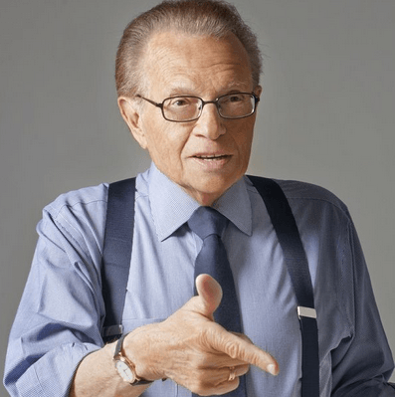

**Here's How This Is Different & Why You Want This Book**

Look. I know how it is. You’ve seen ads like mine before. And maybe you’re wondering, “is this really all that it’s cracked up to be?”

The answer is ... NO.

**It's Even Better.**

Here’s why:

This isn’t some “rah rah” Book where you get a bunch of hyped up “motivation” and then leave empty handed.

Heck - you’re already motivated! Otherwise, you wouldn’t be at this page!

**Here’s Exactly What We’ll Be Doing**

I don’t talk about this much but I had a rough time as a kid.

I was (and am) dyslexic. I never went to college. My parents were married nine times, I had to sleep in the bathroom of one of our houses for almost an entire year once ...and I could go on and on.

And for the longest time I thought that success just wasn’t for me. That it was for other people.

People who went to college. People who had good grades. People who came from the “right” family.

Maybe you’ve felt that way before too.

But then I started to study the habits of millionaires and I realized that they shared a few things in common. And that was a concoction of habits that created their own success formula.

**A SUCCESS FORMULA.**

So I studied them and I learned their formula. And I started to apply it.

...And the rest is history :-)

**SO THE FIRST THING YOU'LL GET FROM THE BOOK IS THE ACTUAL FORMULA.**

Once you have that, you’ll probably start looking at success and money in an entirely new light.

You may find yourself with more confidence, more clarity, and you may be able to act faster with less doubt, stress, or confusion.

And you’ll learn the TRUTH about money.

I’ll tell you now - but this will become crystal clear as you read.

Here it is.

**The Truth About Money:**

**MONEY RESPONDS TO ACTION**

Here’s what I mean.

Do you know how many people in this country hope something will change, things will get better or new "extra" income will suddenly start flowing their way?

Well with the latest research saying over 50% of people "Hate their job" and the staggering amount of people stressed and worried over their finances I'd say the number is HUGE.

There are so many people walking around knowing they have more potential. Knowing they could skyrocket to the top, to their next level, if someone would simply give them the road map or the opportunity.

Well if YOU have that desire I've created the blueprint for massive success in your life.

But it only works if you Take Action..

Why?

Because knowledge without action is simply a dream.

In Millionaire Success Habits I deliver you both. The road map and the secrets that the most successful people in the world use to overcome what's in their way and achieve that next level of life.

**Create Active Cash Flow**

Once you get the formula and you see how to take control of your life and success, the next thing you’ll learn is how to create NEW active cash flow.

This is the money you get every day. It’s the money that you can use to replace a job, or add to your income. You can use it to buy a new car. Pay for college. Go on vacation. Anything you want. It’s yours.

And here’s the thing.

We’re literally living in what I believe to be the most prosperous times in history. (You’ll see why I say this in the Book).

Sure, you’re seeing “doom and gloom” on the news but there’s another side they’re NOT showing you.

There are NEW ways to create active cash flow that never before existed - and they can be started quickly ...without working your life away for years just hoping it’ll “finally work”.

So in the Book, you’re going to see the ONE THING that I’ve used to create more active cash flow than anything else.

And you’ll see exactly what it is and how it works when you read my book and attend your live bonus training this week.

But I’ll tell you something.

NONE OF IT WORKS without the next thing you’re getting, and that’s

**THE ABILITY TO TAKE ACTION**

**AND FOLLOW THROUGH**

May I ask you something?

How many times have you known exactly what to do ...and you’ve even wanted to do it ...but you just, well, didn’t?

Listen. I’ve done it too. We all have. We’ve all had an idea and we just put if off and didn’t follow through.

And the problem is that in so many cases, taking action and following through is the ONE THING that separates people who have massive success ...from those who don’t.

But I’ll give you a secret. The answer isn’t “more motivation”.

And it’s not some sort of “time management” program or anything else. And it’s certainly not a bigger “to do list”.

Instead it’s having a SYSTEM for making sure you stay focused and take action ...so you can get what you really want, fast.

And when you get my book, you’re going to get the same system I use personally.

Think about this. My businesses and brands have literally done hundreds of millions of dollars in sales and I own over $20M of real estate..

I’m on the road A LOT.

But I still have time to coach little league baseball and I NEVER miss a game.

Is it because I’m better organized or smarter? Heck no! I barely finished high school! My secret is a simple SYSTEM for taking action and following through. And when you finally close the book after the last chapter, you’ll have it.

And once you have that, you’re ready for what might be the most important thing of all.

Something you can never lose, no matter what happens to the economy. No matter who’s in office. The ONE THING you can always depend on to get you what you want ...when you want it.

I’m talking about …

**SKILLS THAT PAY**

You already know this: We live in a NEW WORLD.

And it’s no longer a matter of who’s strongest, biggest, or fastest. And it no longer matters where you went to school (or if you went at all), who you know, or any of those old barriers that used to be in your way.

In today’s world, it’s all about this one question:

**Do you have**

**MONEY SKILLS?**

For most people, the answer is “no”.

They never bother to find out what “money skills” are ...much less take the time to cultivate them.

But in this book, you’ll discover what I’ve found to be the highest paying skill in the world.

And before you try to guess what it is, I’ll tell you what it’s NOT.

It's not even a skill that involves handling money!

But this one skill. This SINGLE THING is entirely responsible for ALL of my success ...and it’s responsible for the success of every multi-millionaire I’ve met. Larry King, Richard, Branson, Tony Robbins ...you name it. They’d all tell you the same thing. This is the ONE SKILL that’s truly made them the most.

And the good news is, they don’t teach it in college. Very few people even know about it ...so very few people have it.

But it’s not difficult ...and it can be mastered at any age and I give you the recipe to follow so you can have this skill by the time you are done reading Millionaire Success Habits.

It’s truly staggering ...yet so few people master it (or even know about it!)

So as you can see, this is going to be MUCH MORE than you’re expecting.

I’m 110% positive you’re going to come away from reading this book saying "this was hands down the single BEST read I've ever had”. I know it!

**So Here’s What To Do Next**

Step 1: Go grab your copy of Millionaire Success Habits for free FREE before copies are gone (Or go to Amazon and pay $19.95)

Step 2: Immediately Listen your BONUS interview I did with Tony Robbins on Confidence

Step 3: Make sure to attend the special online training I'll be doing here in just a few days on the new way to wealth and why this area is exploding and perfect for a new side income..

Step 4: Be on the lookout for my book coming to you in the mail. Then Read and take action..

Step 5: Know that because you got my offer today we are going to provide 22 meals to those who need it through Feeding America.

Thanks so much for reading this LONG page and I look forward to hearing from you soon!

Best,

Dean Graziosi

P.S.Look at what people are saying. Remember - you’re getting this book (and more) FREE when you claim you book today:-)

[**Get Your Free Book Now!**Plus All The Bonuses!](https://dgachieve.com/freebook-in?fbclid=IwAR0RcLqUm9AAqnOCufZW7kOHgupLVw0leofhP_DRvsYylgxotPBdjxYcQU8#scroll-order-form)

**Here's What Just A Few Of The People On Amazon Are Saying About Dean's Book (Where It's For Sale For $19.95)**

[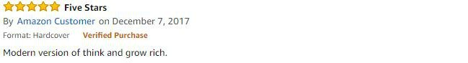](https://dgachieve.com/hosted/images/1d/59d320e1ac11e780a4e3c23bfce2e2/review2.jpg)

[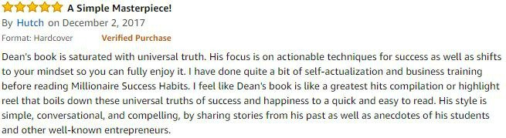](https://dgachieve.com/hosted/images/6f/871e00e1ac11e7ab6621b918f9102f/review4.jpg)

[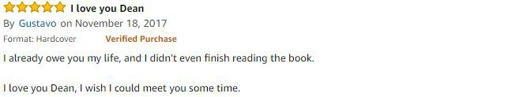](https://dgachieve.com/hosted/images/b8/752940e1ac11e78b7661b1d57b9bc1/review8.jpg)

[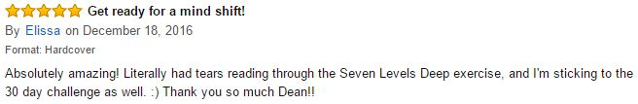](https://dgachieve.com/hosted/images/3c/153e00e1c911e6abe6d78354c5be7b/5.1.jpg)

[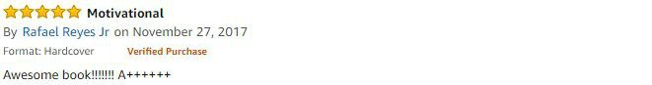](https://dgachieve.com/hosted/images/39/dc2510e1ad11e79f5d974bccf3160e/review6.jpg)

[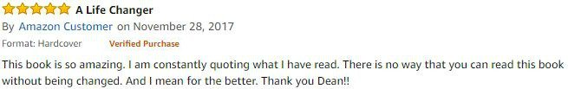](https://dgachieve.com/hosted/images/7b/c417d0e1ad11e7ab6621b918f9102f/review5.jpg)

[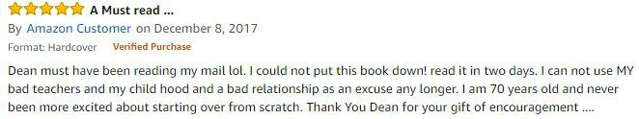](https://dgachieve.com/hosted/images/b1/e339e0e1ad11e798a167cbedd0e5ab/review1.jpg)

[**Get Your Free Book Now!**Plus All The Bonuses!](https://dgachieve.com/freebook-in?fbclid=IwAR0RcLqUm9AAqnOCufZW7kOHgupLVw0leofhP_DRvsYylgxotPBdjxYcQU8#scroll-order-form)

**What People Are Saying About Learning From Dean Graziosi**

"The best thing about my life after meeting Dean is I have so much more freedom. I have control over my time, I get to spend every single summer with my kid, I've been able to travel a bunch, been able to help out friends and family and have been able to volunteer. Now I have the freedom to do what I want to do and live the life that I want.

- Andrea Weule

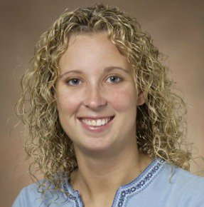

“By following and learning from him, we’ve gained so much confidence… We have built our business up, we're making very good income. Dean has taught me to change your whole thinking and it changes your life.. If you can change your whole outlook, things do change.”

- John & Julie Wakefield

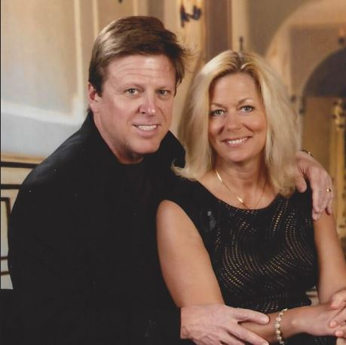

"One of the things that's so rewarding now, is that my children look at my in a new way. They look at me with a different admiration and tell me they're proud of me. Being in complete control of your financial life, allows you to discover a better version of yourself."

- Gena Horiatis

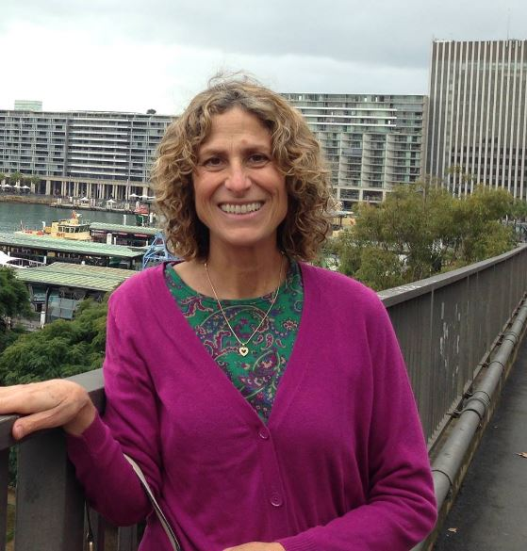

"What I've learned from Dean, I've been able to gain the confidence that I can control my own destiny. I get to spend more time with my family, go on more vacations and travel the world. It's been amazing.

- Jay St. Hilaire

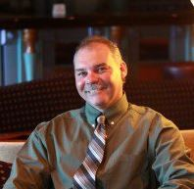

**Hurry & Get EVERYTHING Below Today Before It’s Gone...**

* **Free Millionaire Success Habits Hardcover Book (On Amazon For $19.95)**
* **The 5 Best Ways To Make Money In 2018 - A Round Table Training With Dean & His Dream Team (Rare Training - Value $297)**
* **Exclusive “Confidence Builder” Interview With Tony Robbins (Value $97)**
* **Dean Will Donate To Feeding America And Provide 20 Meals To Those In Need (Priceless)**
* **Access To The Better Life Challenge & A Shot To Win Dean's Tesla (Priceless)**
* **Get A Seat To An Online Webclass Training Where Dean Will Reveal What They Believe What He Believes Is The #1 Way To Profit From Today's Economy (Value $297)**

[**Get Your Free Book Now!**Plus All The Bonuses!](https://dgachieve.com/freebook-in?fbclid=IwAR0RcLqUm9AAqnOCufZW7kOHgupLVw0leofhP_DRvsYylgxotPBdjxYcQU8#scroll-order-form)

© 2018 BBG Enterprises LLC | Scottsdale AZ | Www.Deangraziosi.Com | Csmanager@Deangraziosi.Com

[**Home**](http://www.deangraziosi.com/)**|**[**Contact Us**](http://www.deangraziosi.com/support)**|**[**Terms, Conditions & Privacy Policy**](https://dgachieve.com/terms-and-conditions)